Member Management Module

Introduction
The Member Management module allows administrators and staff to add and manage member records in the ChurchCMS portal. This module helps maintain complete member information for communication, identification, and portal access.

How to Add a Member

Step-by-Step Procedure
- Login to the system using Admin or Staff credentials.
- From the left navigation pane, go to Users.
- Click Members.

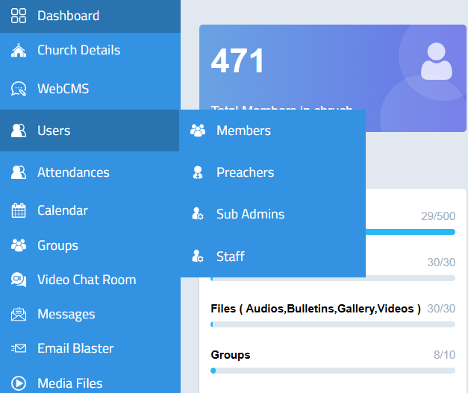

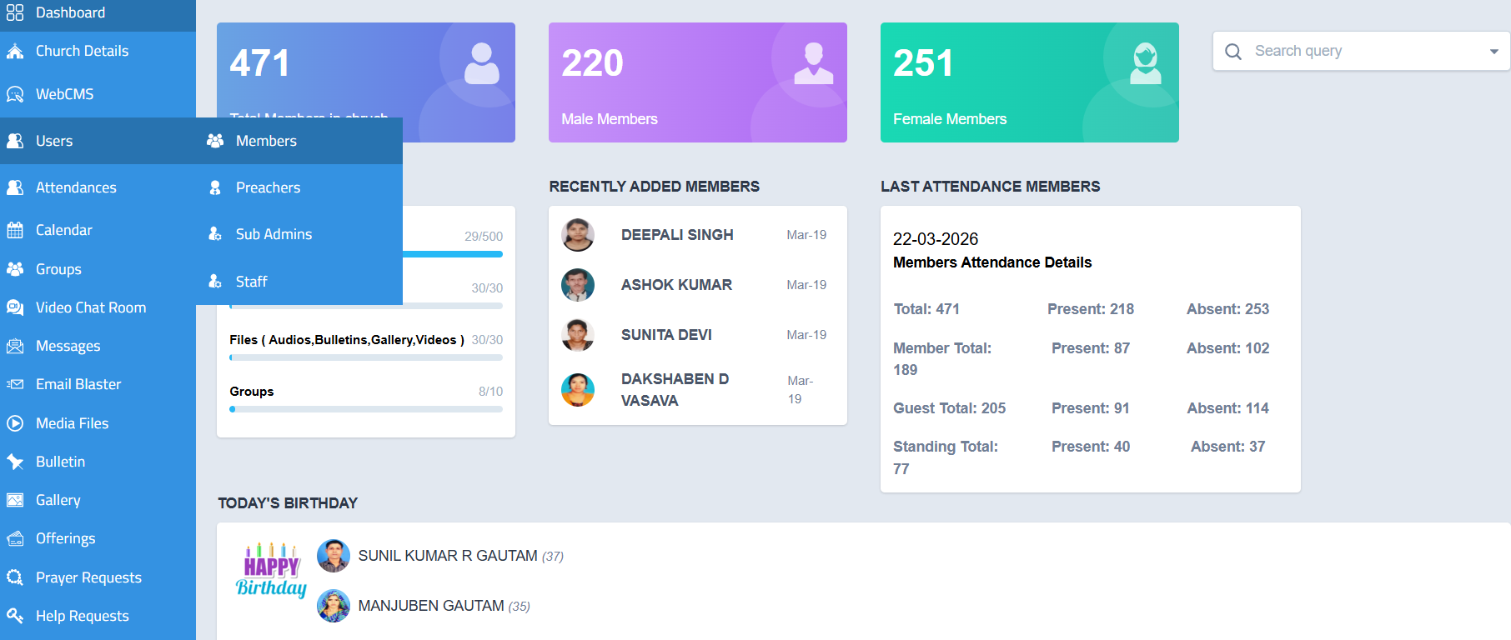

Adding a New Member
- On the top-right corner of the Members page, click the Add button.
- A new member registration form will open.
- Enter all the required details, such as:
  - Full Name
  - Email ID
  - Phone Number
  - Aadhar Number
  - Employment ID
  - Date of Birth
  - Other relevant member information
- After entering all the details, click Submit.
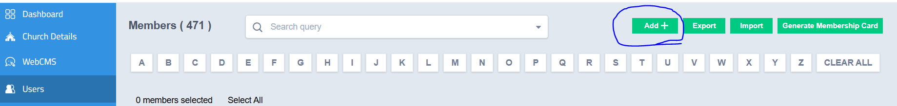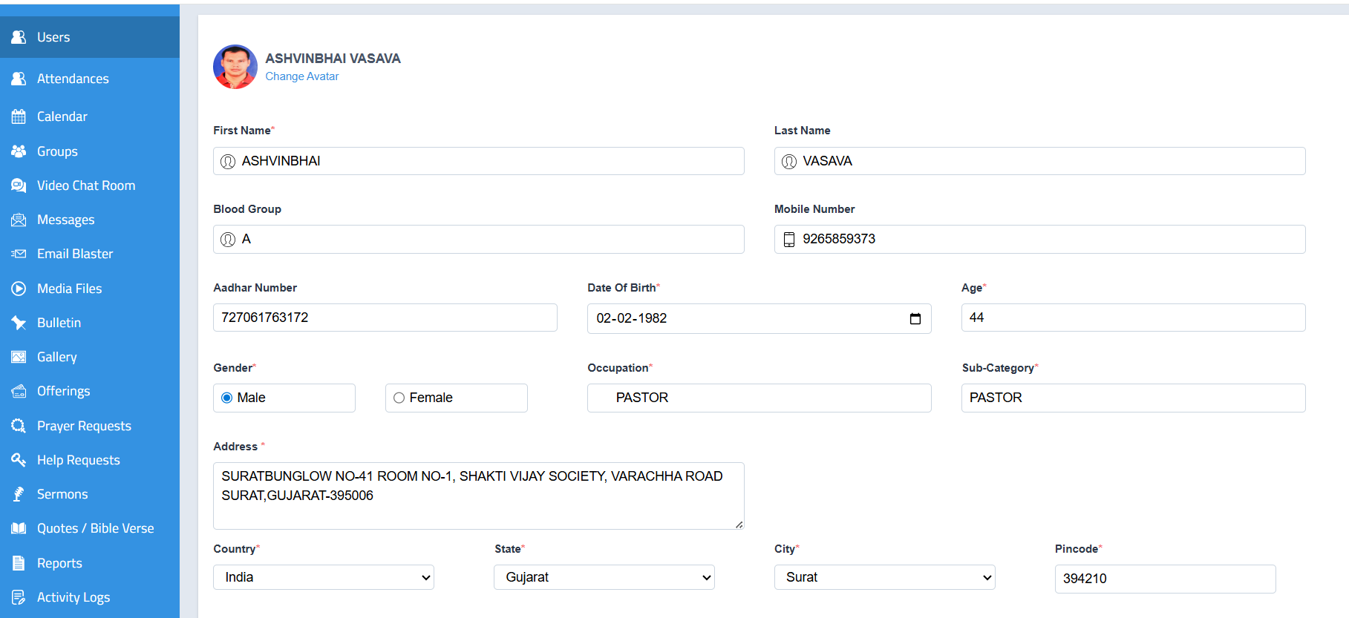
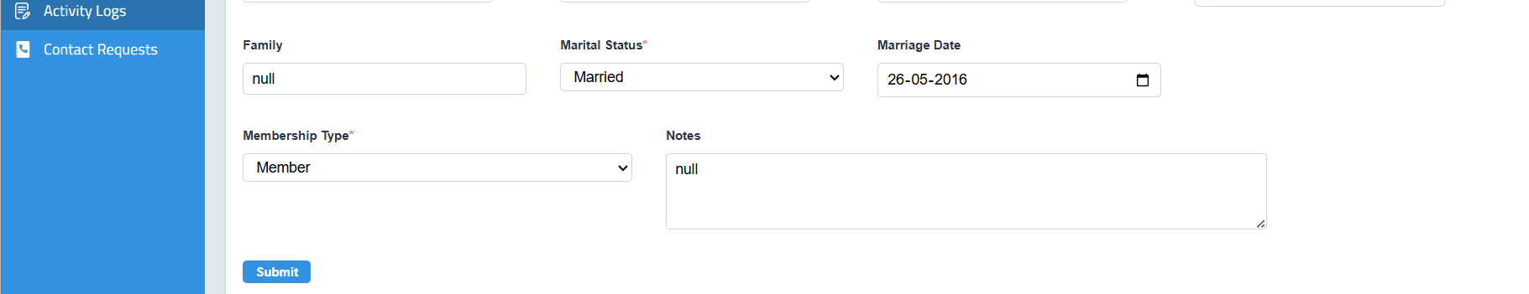

Outcome
- The member will be added successfully to the portal.
- The newly added member will appear in the Members list.
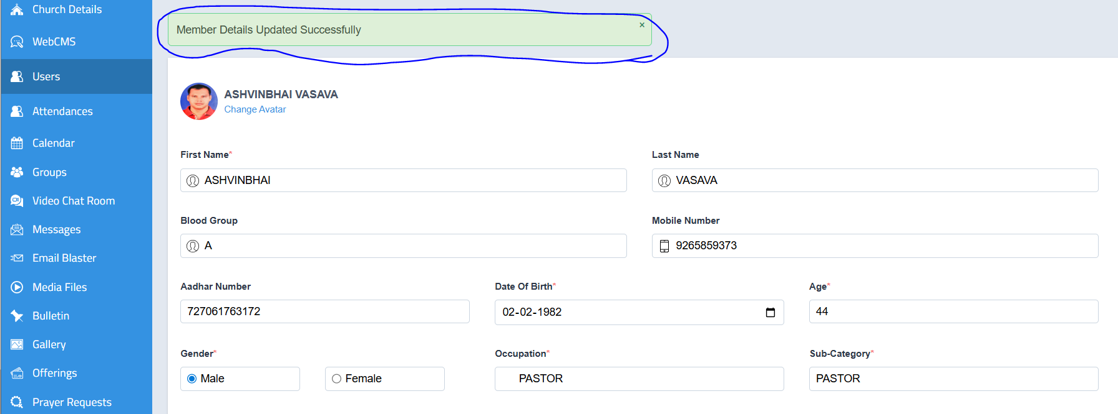

Note
- Ensure that the Email ID entered is valid, as it may be required for member login and communication.

How to View Member Details

Step-by-Step Procedure
- Login to the system using Admin or Staff credentials.
- From the left navigation pane, click Users.
- Select Members.
- The Members List will be displayed.
- Click on the required Member Name to open the full member profile.
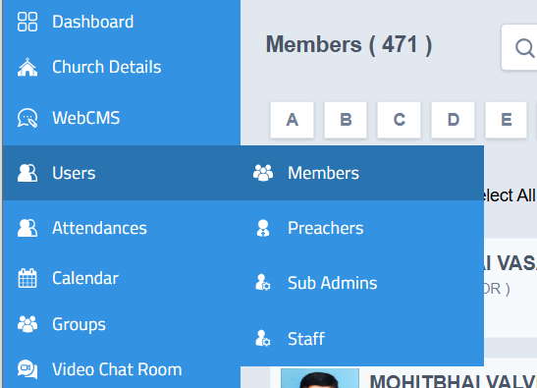
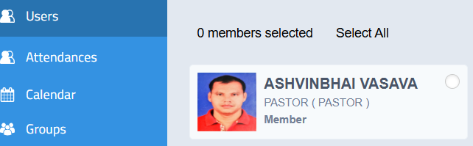

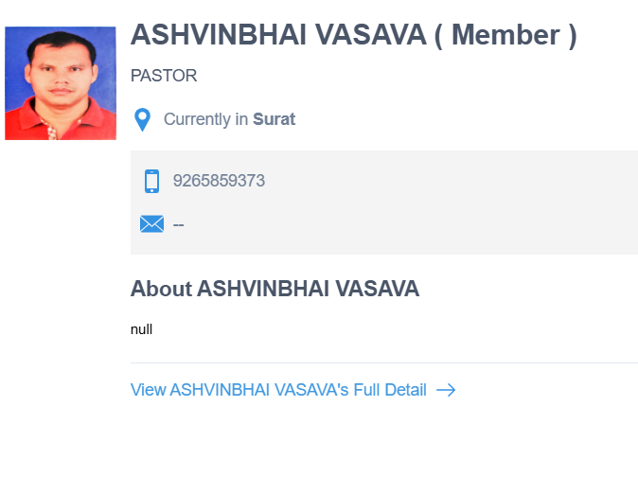

Member Profile Sections
The following tabs and details can be viewed in the member profile:

1. Profile
- Displays the complete profile information of the member.
- Includes personal details such as name, contact information, date of birth, and other registered details
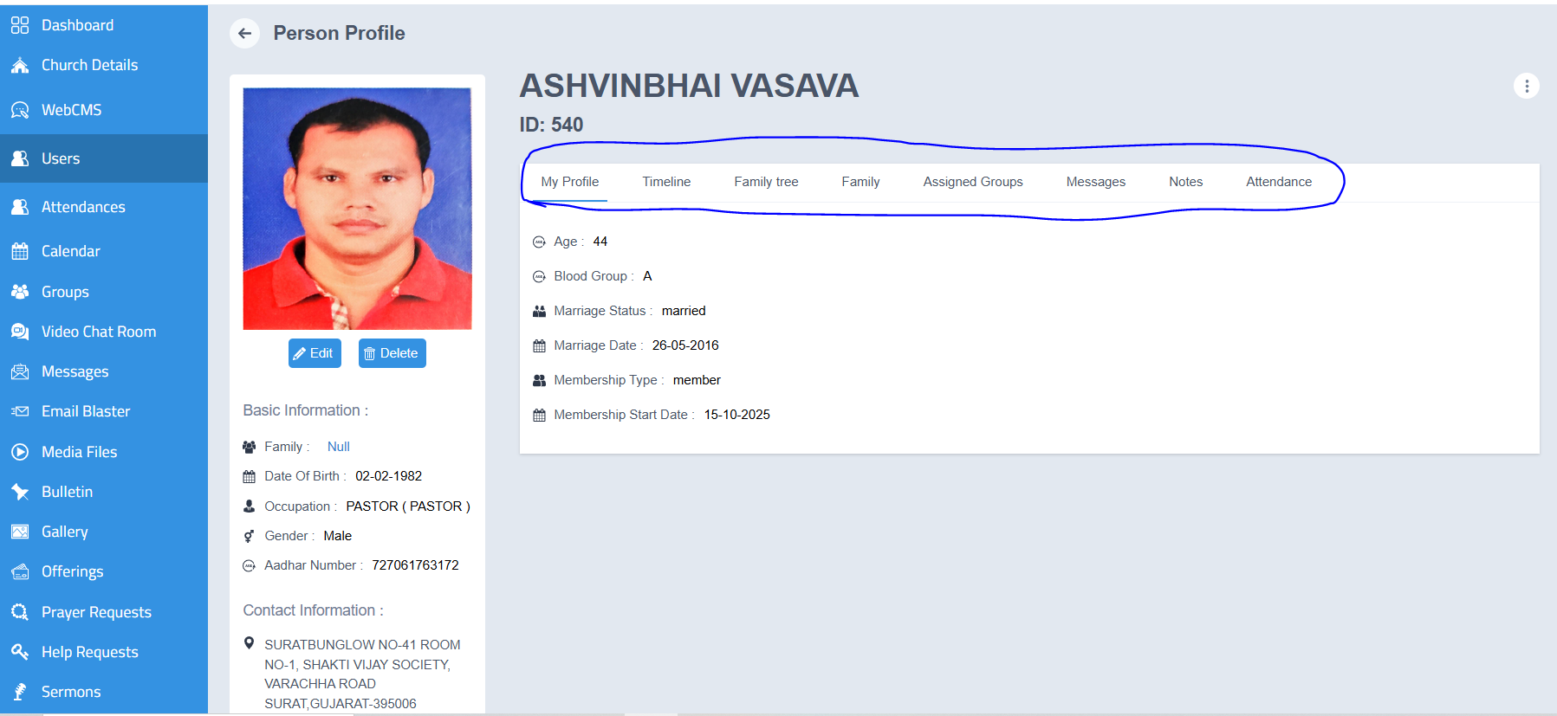
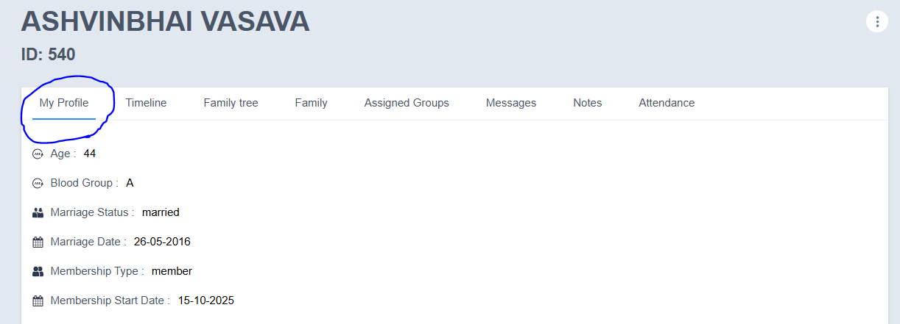

2. Timeline
- Displays the activity history of the member profile.
- All updates and actions performed in the profile can be viewed here.
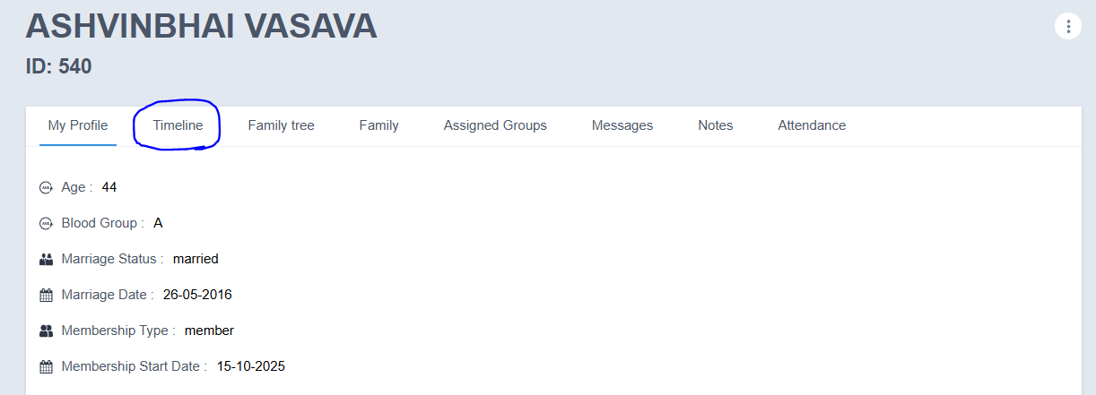
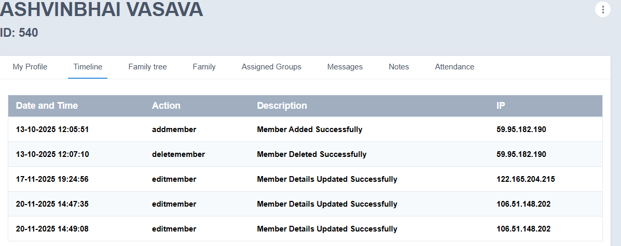

3. Family Tree
- Displays the family details linked to the member.
- Family information such as:
  - Name of the family member
  - Relationship
  - Date of Birth
  - Email ID
  - Other related details
can be viewed here.

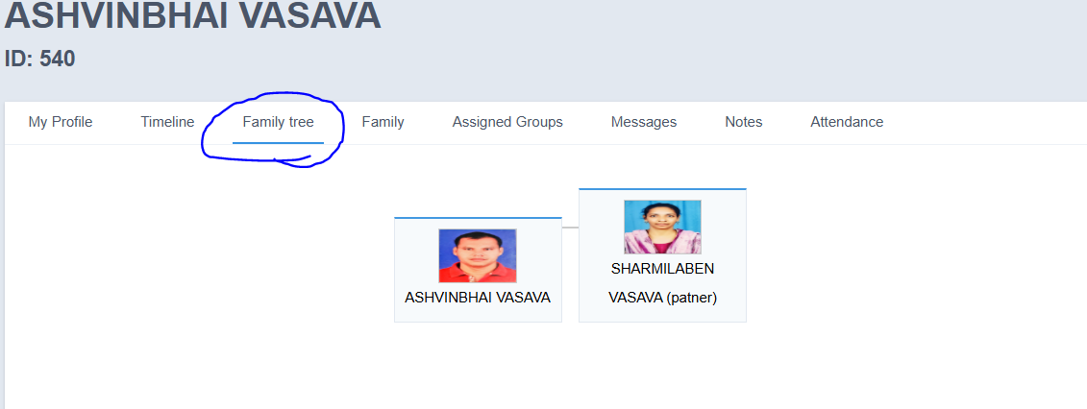
- Family
- Family tree details can be added while creating the member profile in the Users module.

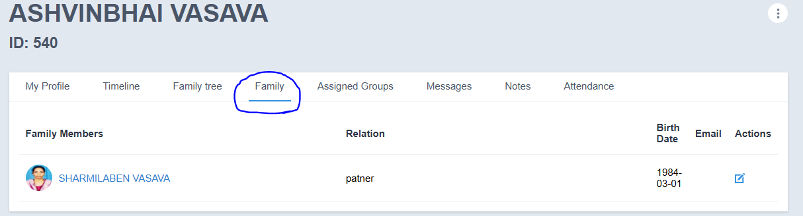

5. Assigned Groups
- Shows the groups to which the member has been assigned.

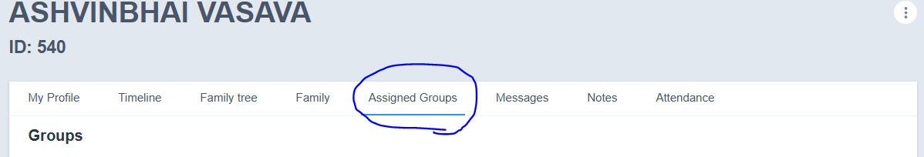

6. Messages
- Displays messages sent by the member.
- The following details can be viewed:
  - Status
  - Subject
  - Message
  - Attachments
  - Sent On
  - Action
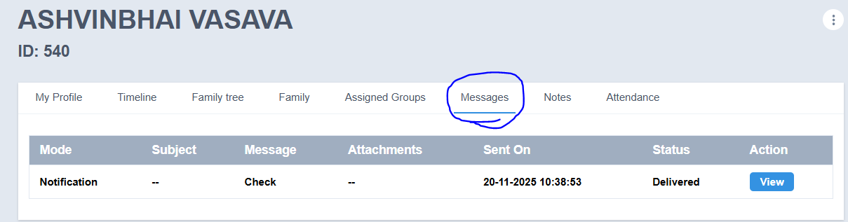

To View a Message
- Click the View button next to the required message.
- The full message details will be displayed.
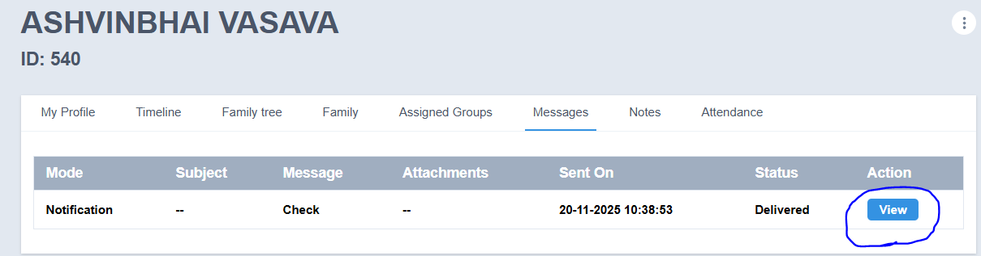
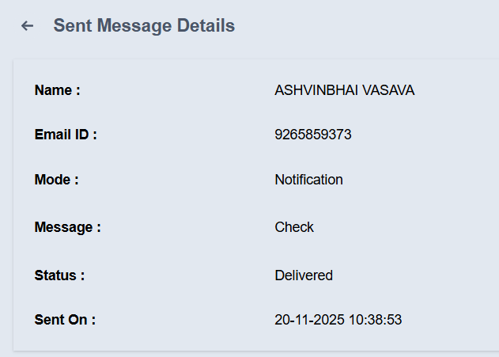

7. Notes
- Admin can add notes related to the member.
- Enter the note in the provided field.
- Click Submit to save the note.
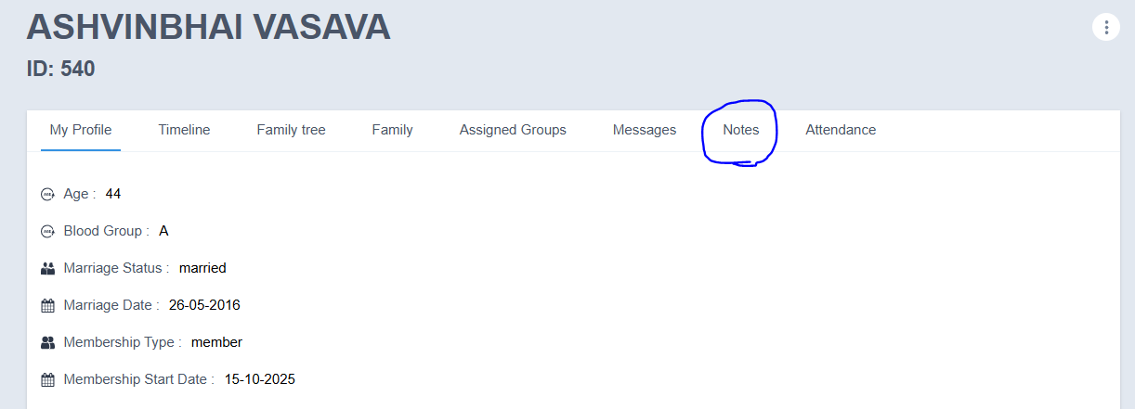
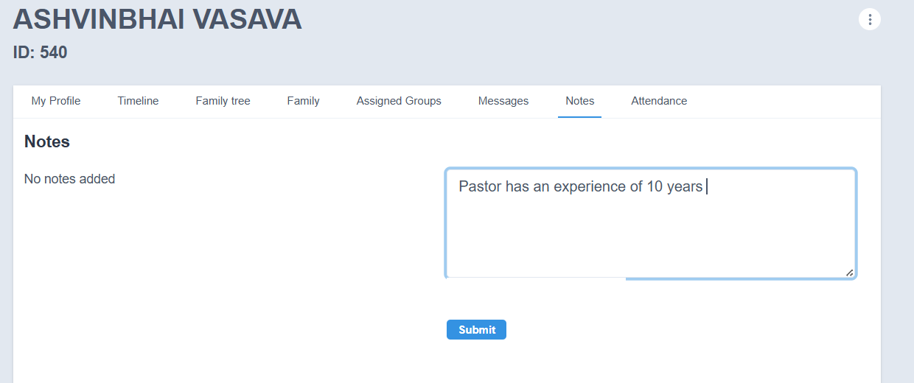

8. Attendance
- The attendance details of the member can be viewed in this section.

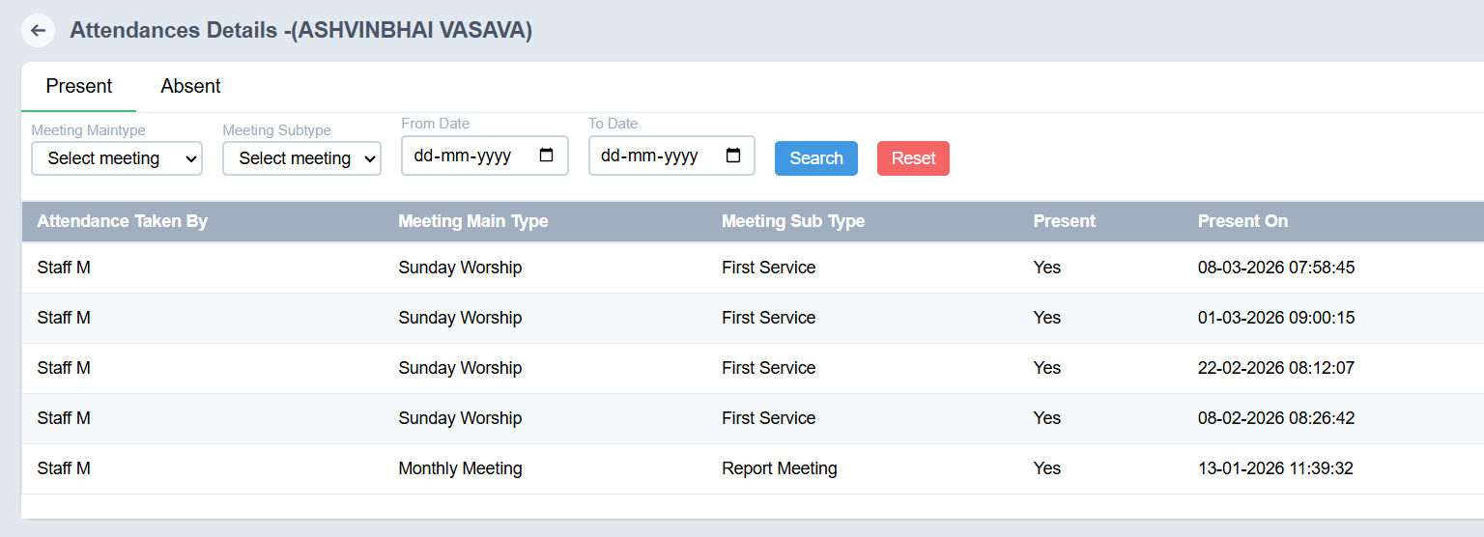

Edit Member Profile
- Open the required member profile.
- Click the Edit option.
- Make the necessary changes.
- Click Submit to save the updated details.
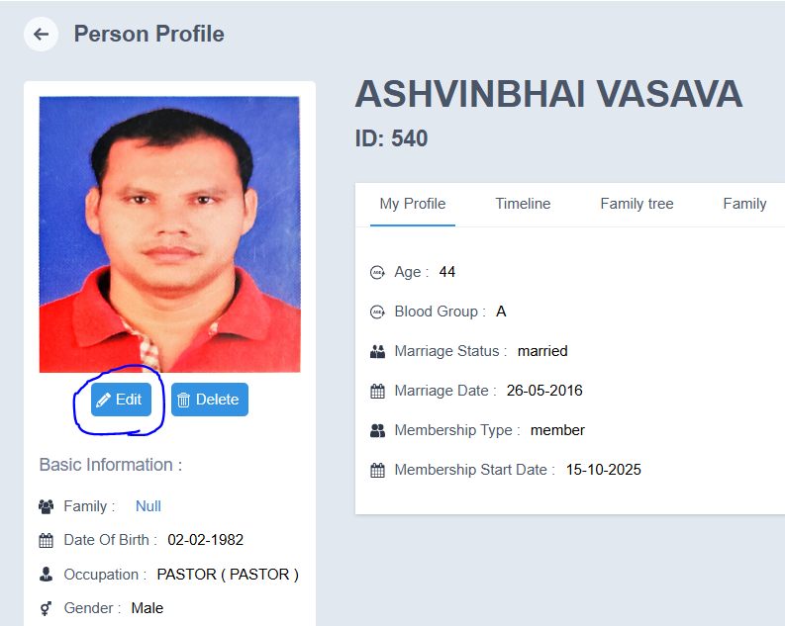
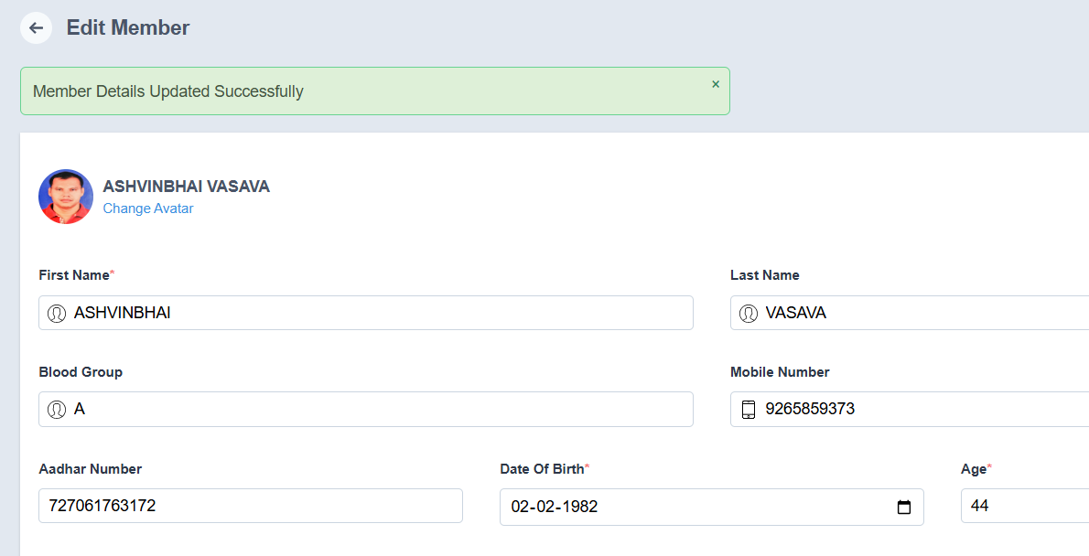

Delete Member Profile
- Open the required member profile.
- Click the Delete option.
- Confirm the deletion.
- The member record will be deleted successfully.

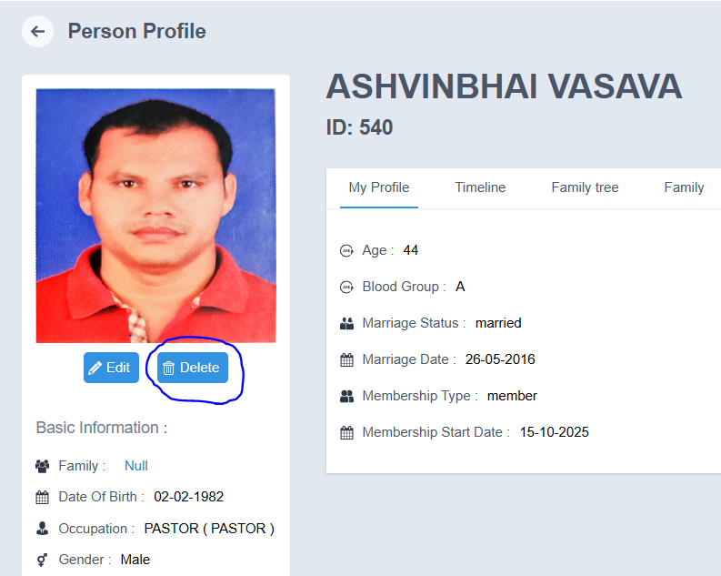
Conclusion
The Member Details section provides a complete overview of each member’s profile and related activities, helping administrators and staff manage member information efficiently.

Member Profile Actions
The Member Profile Actions menu allows administrators and staff to perform important account and communication tasks directly from a member’s profile. These actions help manage member status, communication preferences, family details, and membership records efficiently

How to Access Member Profile Actions
- Login to the system using Admin or Staff credentials.
- Navigate to Users → Members.
- Open the required Member Profile.
- Click the three-dot (⋮) menu at the top-right corner of the profile page.
- A list of available actions will be displayed, such as:
  - Deactivate
  - Reset Password
  - Verify Email
  - Subscribe Newsletter
  - Messaging
  - Add Family Member
  - Generate Membership Card
  - Exit Member
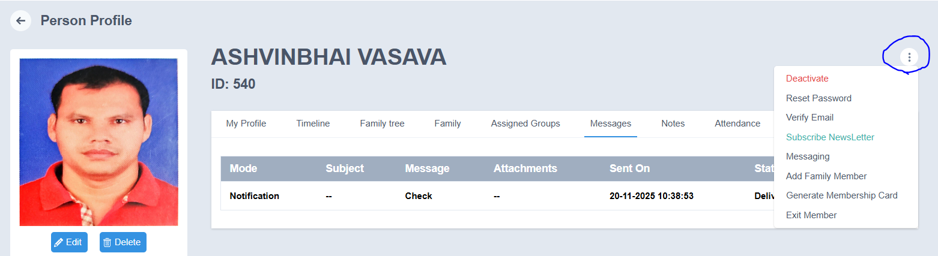

Available Member Profile Actions

1. Deactivate Member
- Click Deactivate.
- A confirmation message will appear asking whether you want to change the member’s status.
- Click OK.
- The member will be deactivated successfully.
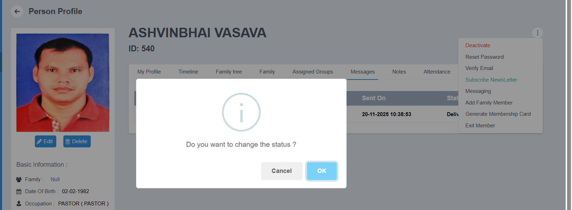

2. Reset Password
- Click Reset Password.
- The member’s password will be reset successfully.
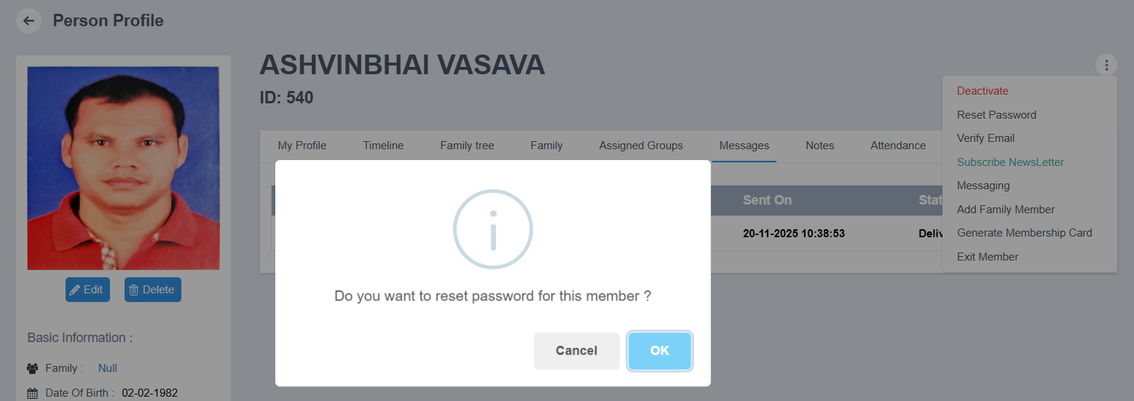

3. Verify Email
- Click Verify Email.
- A verification email will be sent to the member’s registered email address.
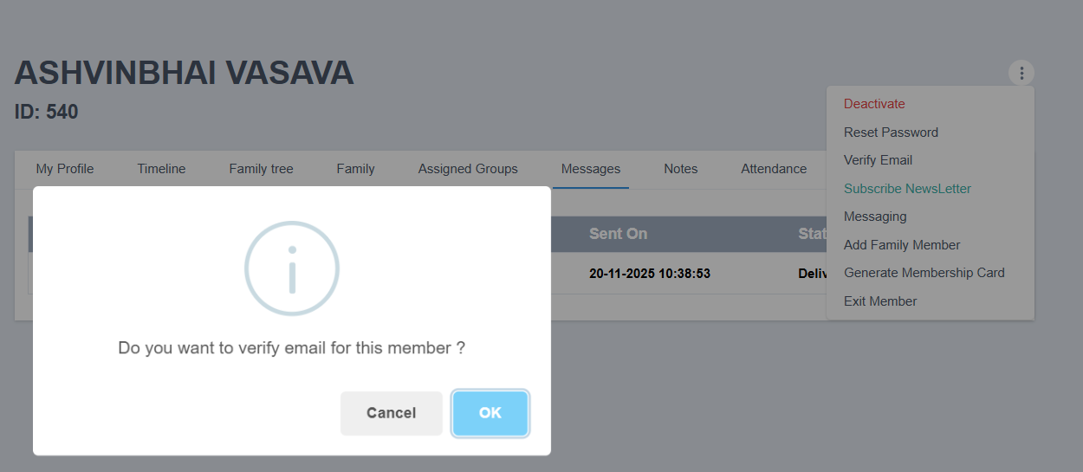

4. Subscribe to Newsletter
- Click Subscribe Newsletter.
- The newsletter subscription status of the member will be updated.
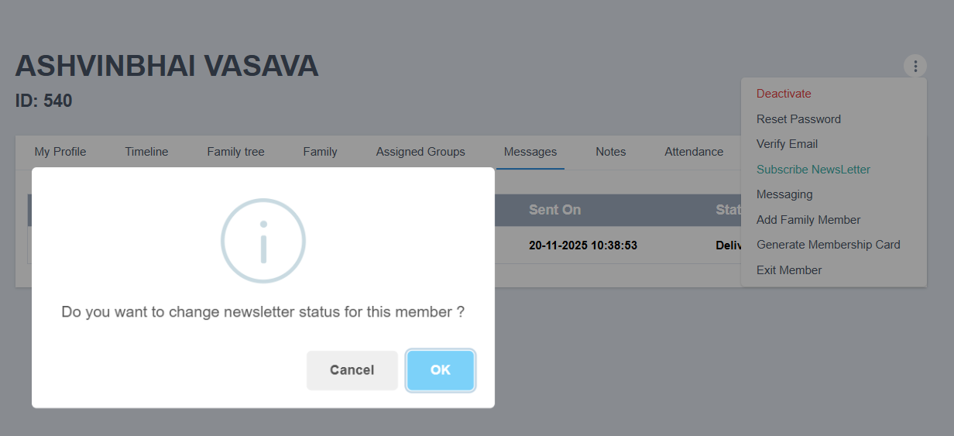

5. Send Messages
The system allows communication with members through different channels.
- Click Messaging.
- Choose the required communication method:
  - Message
  - Email
  - SMS
- Enter all the required details.
- Click Send.

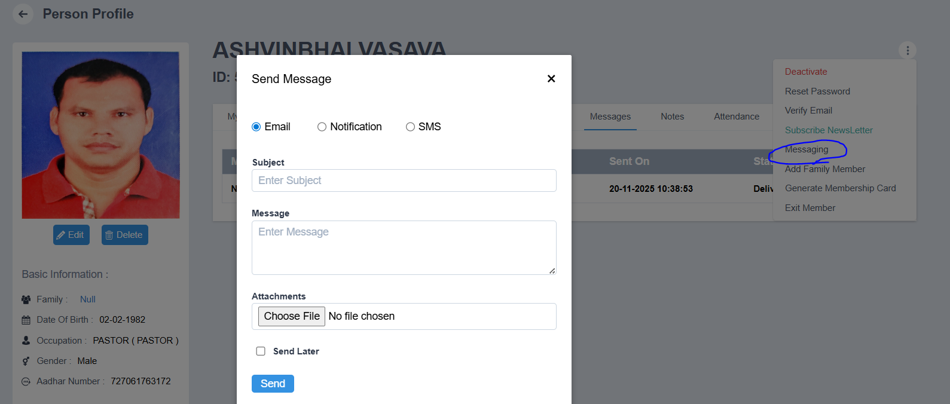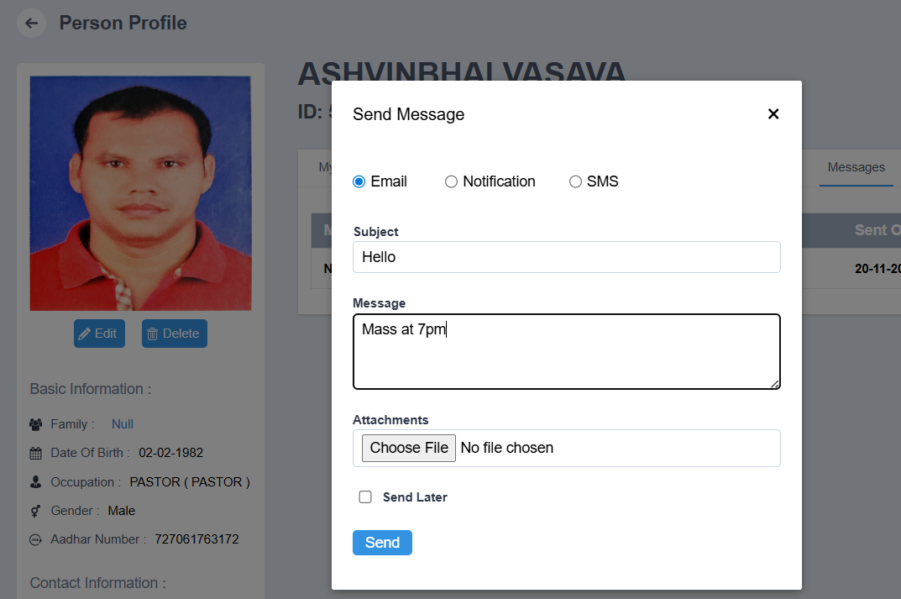

6. Add Family Member
- Click Add Family Member.
- Enter all the required details, such as:
  - Relationship
  - Name
  - Gender
  - Blood Group
  - Aadhar Number
  - Mobile Number
  - Other relevant details
- Click Submit.
- The family member will be added successfully.
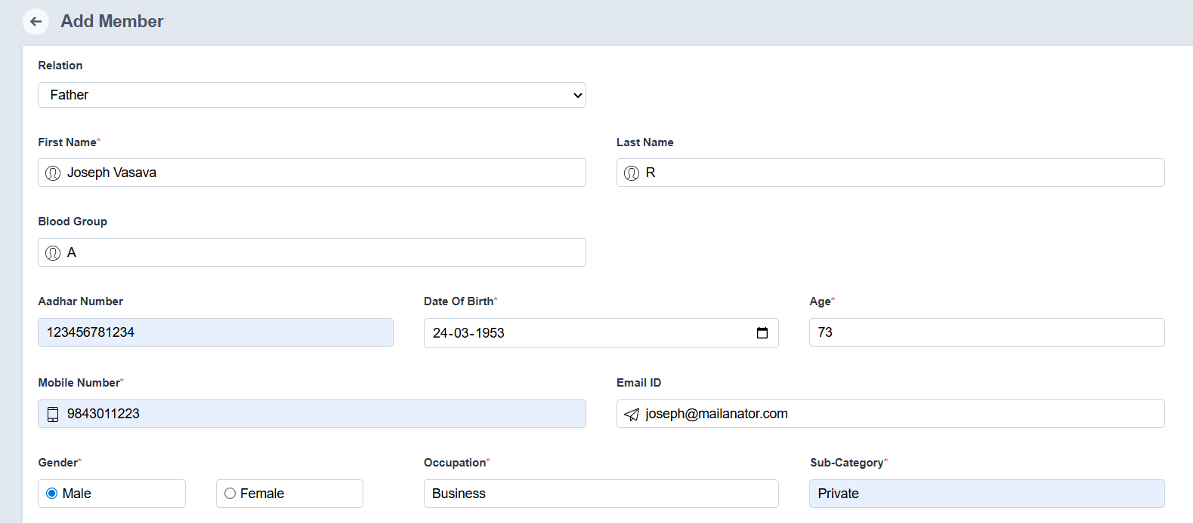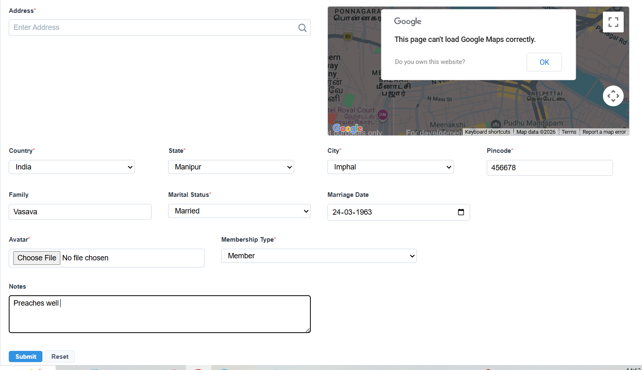

7. Generate Membership Card
- Click Generate Membership Card.
- The membership card will be generated instantly.

8. Exit Member
- Click Exit Member.
- Confirm the action.
- The member will be marked as exited from the portal.

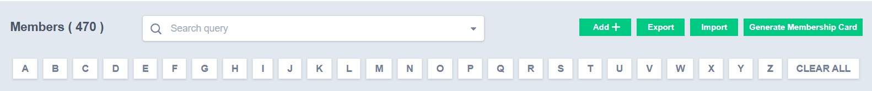

Additional Member Management Actions
The Member Management module also provides quick options to export, import, and generate membership cards for members.

Export Contacts
- Member contact details can be exported easily for reporting, backup, or external use.

Import Contacts
- Member contact details can be imported easily into the system for bulk record creation or updates.

Generate Membership Card
- Membership cards can be generated with just a few clicks for registered members.
Note: Generated membership cards can be printed for physical use.
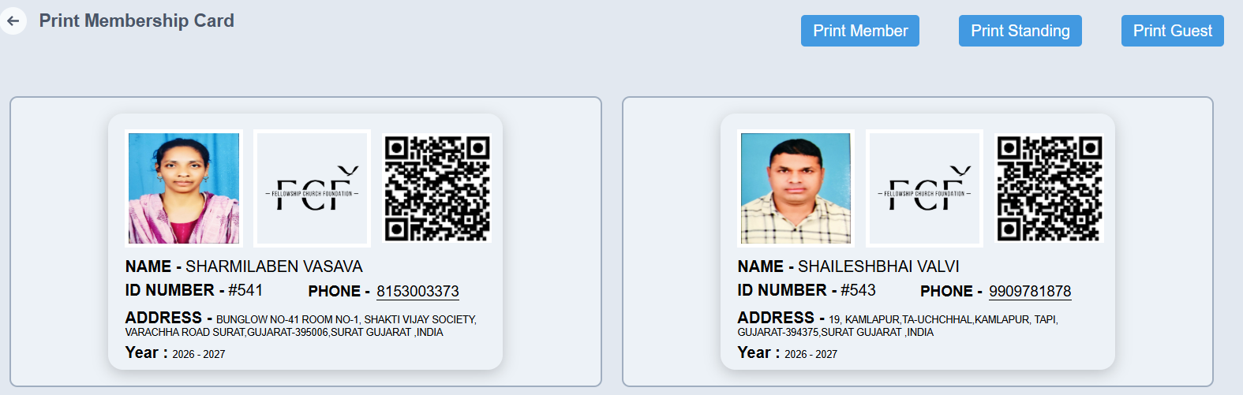
Note: Membership cards can be printed for physical use.

Notes
- Ensure all required details are entered correctly before submitting any action.
- Some actions may require confirmation before they are completed.
- Generated records and status changes will be reflected immediately in the member profile.

Conclusion
The Member Profile Actions menu provides quick access to important administrative functions, making it easier to manage member accounts, communication, and family information from a single location.

